# **TAX INVOICE** Date:12/08/19 From: Eli’s Garden Improvements, 34a Windsor st Perth ABN: 29 312 028 484 To : Jan Lewis, Unit 6, 24 Canning Avenue, Mount Pleasant **Scope:** Usual garden maintenance Spray Seasol over entire garden

|  |  |  |  |
| --- | --- | --- | --- |
| **Qty** | **Description** | **Cost** |  |
| 2hrs | Labour | $70. | 00 |
| 1 | Seasol Powerfeed | $10. | 00 |
|  |  |  |  |
|  |  |  |  |
|  |  |  |  |
|  |  |  |  |
|  | **Total:** | **$80.** | **00** |

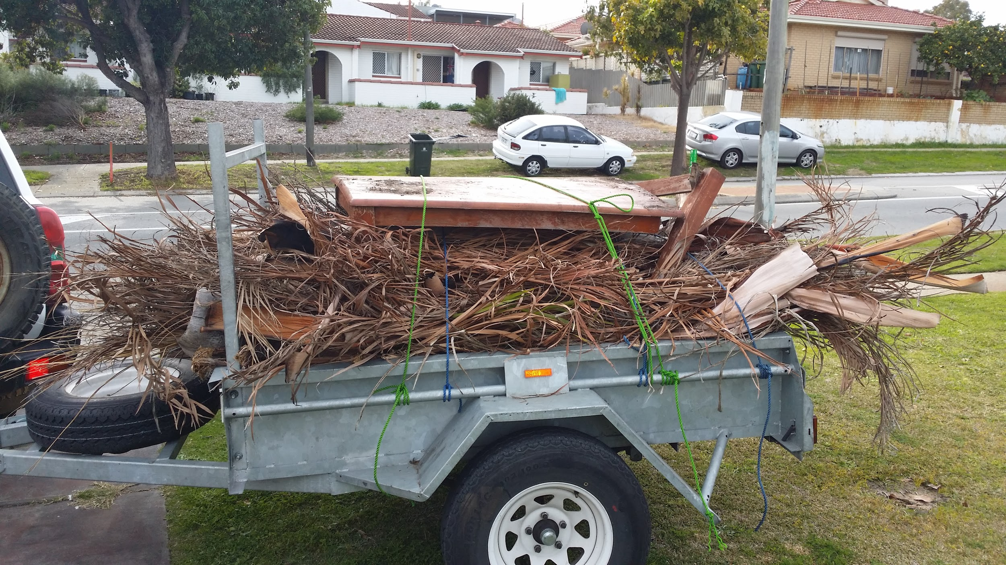

Payment Details:  
Please Pay **$80.00:**

**Eli Simic Robertson**

**BSB: 086006**

**ACC: 831081868**

Please pay within 7 working days.